LAB 321Assignment | Type: | LongAssignment
LAB 321Assignment | Code: | J3.L.P0063
LAB 321Assignment | LOC: | 250
LAB 321Assignment | Slot(s): | 10

Title: Search Restaurant Information

Background
Restaurant provide services that customer can order a party online

Program Specifications

Program a web site display list of services and a page that allow a user to add new/edit a service

Features:

This website contains following main functions
- Function 1: Search Service
  - The service will be searched by restaurant name, address
  - The service list must be paging
- Function 2: Add Service Details
  - List of rating information
  - Rating
  - Detailed information of service
- Function 3: Edit Service Details

Database description
- Database must contain service detail information displayed on the screen

Expectation of User interface:

PIC 1: Search Services

Note: The following fields must be displayed
- Service Name
- Price
- Status
- Service Type
- Previous/Next button
- Search button and Service Name, Service Type
- Edit button : When user click on “Edit” button, the system will display the Edit Service like page as PIC02
- Input Search field. When user click on “Search” button, the system will search all service which match service name and service type
- Add Service button: When the user click on “Add Service” button the system will display the Add New Service page as PIC02

PIC 2: Add Service

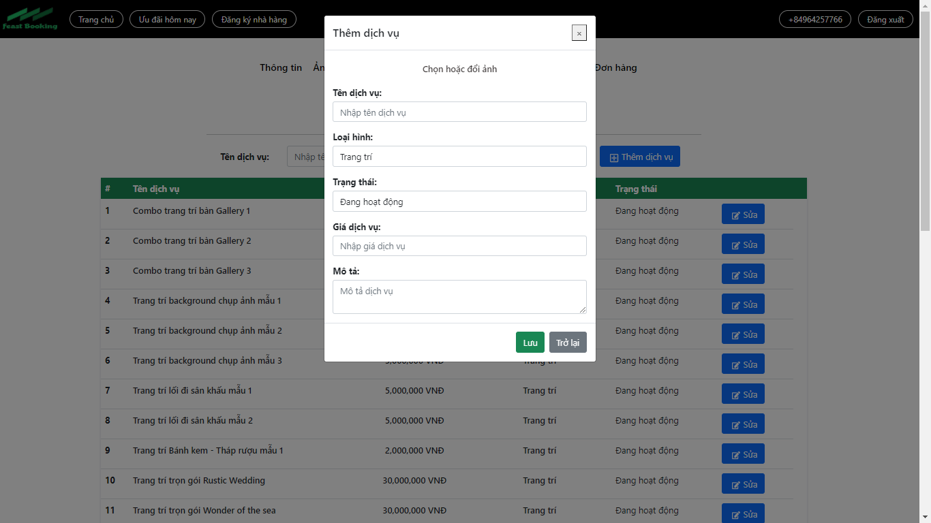

Note: The following fields must be displayed
- All fields in the screen must be got from database
- When user click on “Back”, the service list will be displayed
- When user click on “Save”, the service list will be displayed

Guidelines
- Step 1 : Create web layout
- Step 2 : Create prototype
- Step 3 : Design database base on created prototype
- Step 4 : Code & Test

